Human Brain

[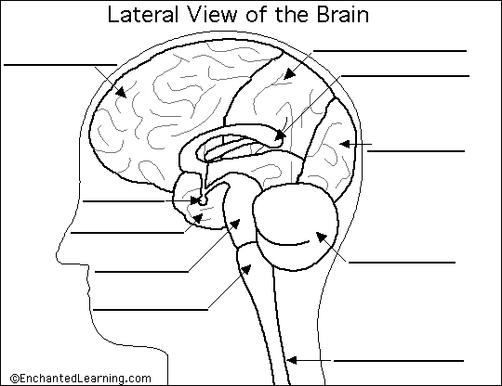](https://www.google.com.au/url?sa=i&rct=j&q=&esrc=s&source=images&cd=&cad=rja&uact=8&ved=2ahUKEwi84Nup1vbhAhWEF3IKHfaoDVIQjRx6BAgBEAU&url=https://www.enchantedlearning.com/subjects/anatomy/brain/label/lateralbrain/label.shtml&psig=AOvVaw28y5YNSVIz-FJTB8J2mpY2&ust=1556674015165796)

[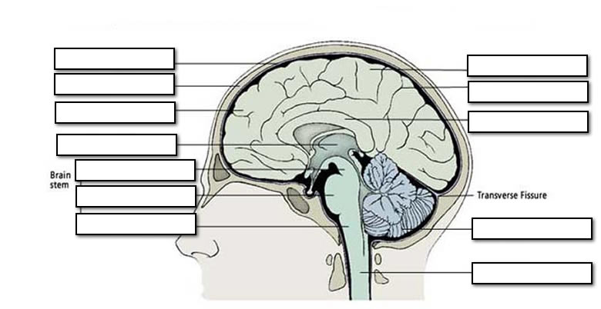](https://www.google.com.au/url?sa=i&rct=j&q=&esrc=s&source=images&cd=&cad=rja&uact=8&ved=2ahUKEwi2gIDC1fbhAhXRYisKHRCyCr0QjRx6BAgBEAU&url=https://oaklandeffect.com/galery/label-parts-of-the-brain-worksheet.html&psig=AOvVaw28y5YNSVIz-FJTB8J2mpY2&ust=1556674015165796)